PHASE 3: Flow Designer Automation

1. Objectives
- To automate the classification of IT support tickets using ServiceNow Flow Designer.
- To analyze the Short Description of the ticket for predefined keywords.
- To automatically assign the appropriate Category and Subcategory.
- To reduce manual classification effort and human errors.
- To send an automated email notification to the caller after ticket creation.
- To implement the solution using a no-code and maintainable approach.

2. Activities Performed
Activity 1: Flow Creation
- Open Flow Designer.
- Create a new Flow.
- Flow Name: Auto Classify School IT Tickets.
- Application: Global.
Activity 2: Trigger Configuration
- Trigger: Record Created
- Table: Incident Workflow
- Condition: Category is Empty
Activity 3: Wi-Fi Issue Classification
- Check whether Short Description contains Wi-Fi or Network.
- Category → Network
- Subcategory → Wi-Fi
Activity 4: Projector Issue Classification
- Check whether Short Description contains Projector.
- Category → Hardware
- Subcategory → Projector
Activity 5: Password Issue Classification
- Check whether Short Description contains Forgot Password.
- Category → Access
- Subcategory → Forgot Password
Activity 6: Slow Computer Classification
- Check whether Short Description contains Slow Computer.
- Category → Performance
- Subcategory → Slow Computer
Activity 7: Email Notification
- Send an email to the Caller.
- Configure the email subject and ticket confirmation message.
- Activate the Flow after configuration.

3. Expected / Produced Output
After successful execution of the Flow:
Input Keyword | Category | Subcategory
Wi-Fi / Network | Network | Wi-Fi
Projector | Hardware | Projector
Forgot Password | Access | Forgot Password
Slow Computer | Performance | Slow Computer

Produced Output:
- IT ticket is automatically classified.
- Category and Subcategory are updated automatically.
- Manual classification is reduced.
- A confirmation email is sent to the caller.
- The ticket classification process becomes consistent and maintainable.

4. Data Flow Diagram
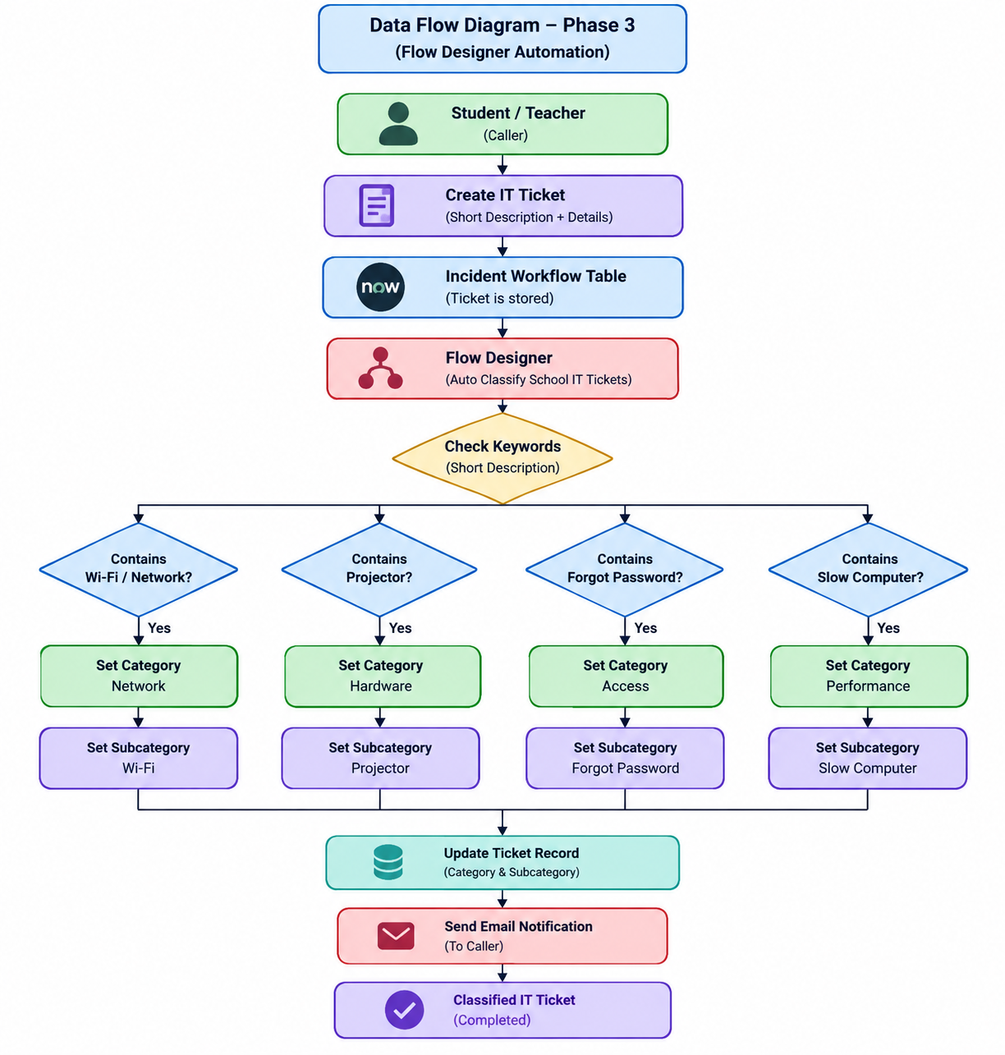
Data Flow:
Caller → IT Ticket → Flow Designer → Keyword Analysis → Category/Subcategory Assignment → Email Notification → Classified Ticket.

